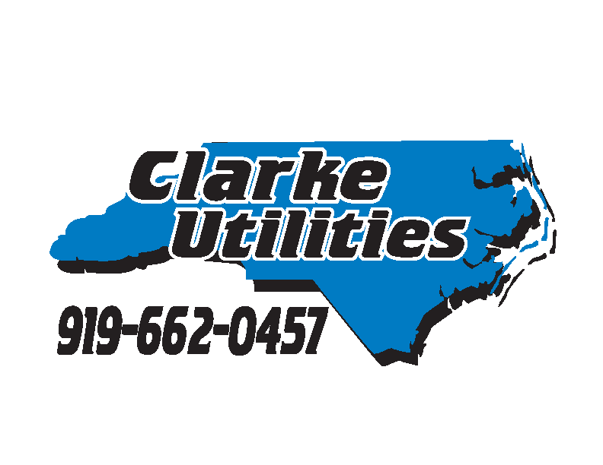 Clarke Utilities
East Pointe Building
223 Hwy. 70 East, Suite 115
Garner, NC 27529
Email: joel@clarkeutilities.com

AUTHORIZATION FOR AUTOMATIC BANK DRAFT

DATE OF AUTHORIZATION: Click or tap to enter a date.

I authorize Clarke Utilities, INC. to initiate electronic debit entries to my:Choose an item.

I ACKNOWLEDGE THAT THE ORIGINATION OF THE ACH TRANSACTIONS TO MY ACCOUNT MUST COMPLY WITH THE PROVISIONS OF US LAW. THIS AUTHORITY WILL REMAIN IN EFFECT UNTIL I HAVE CANCELLED IT IN WRITING.

CUSTOMER INFORMATION

Name: Click or tap here to enter text.

Utility Account Number: Click or tap here to enter text.

Phone Number on Account: Click or tap here to enter text.

EMAIL Address: Click or tap here to enter text.

FINANCIAL INSTITUTION INFORMATION

Financial Institution Name: Click or tap here to enter text.

Financial Institution Address: Click or tap here to enter text.

Account Number at Financial Institution: Click or tap here to enter text.

Routing Number at Financial Institution: Click or tap here to enter text.

DELIVERY OPTIONS: Print Completed Form and Submit as Below:
☐EMAIL: A SCANNED COPY OF A VOIDED CHECK MUST ACCOMPANY THIS AUTHORIZATION
☐MAILING: A VOIDED CHECK MUST ACCOMPANY THIS AUTHORIZATION

CUSTOMER SIGNATURE: Click or tap here to enter text.

